Agriculture and Rural Development

Contrast in percent of labor force in developing (low and middle income) to high income

Contrast in percent of GDP from agriculture in developing and high income.

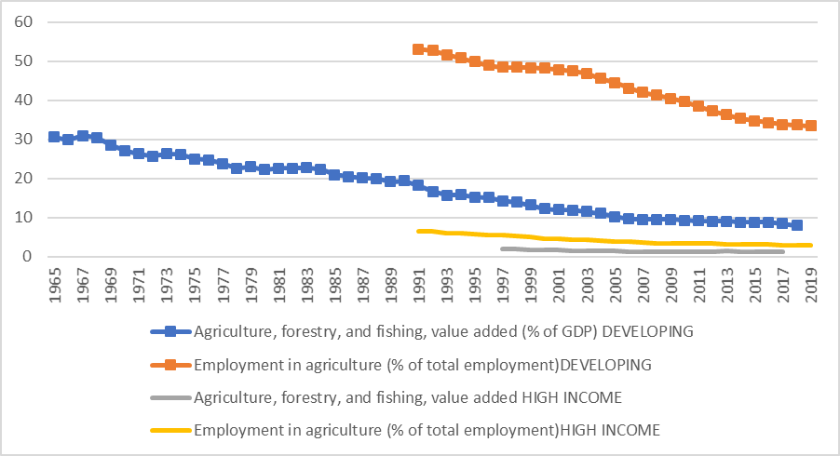

WDI online

Some Regional Differences in Agriculture as share of GDP

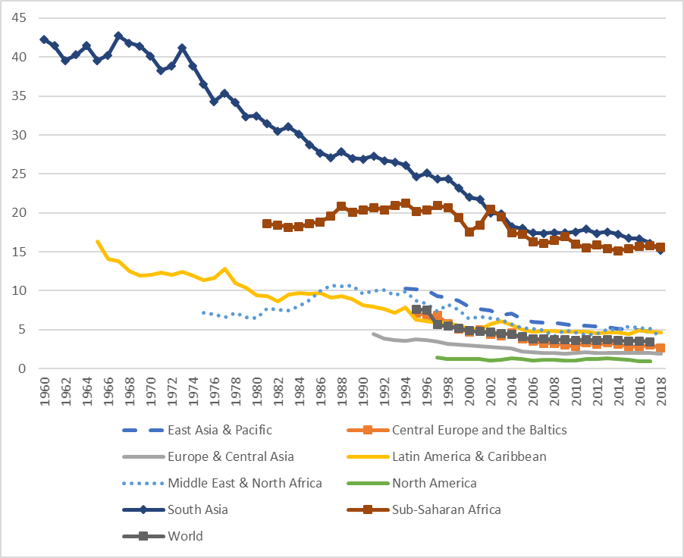

WDI online agriculture, forestry, fishing value added as % of GDP

% of labor force in agriculture by regions 1961 to 2004 (World Resources Institute Earthwatch – discontinued)

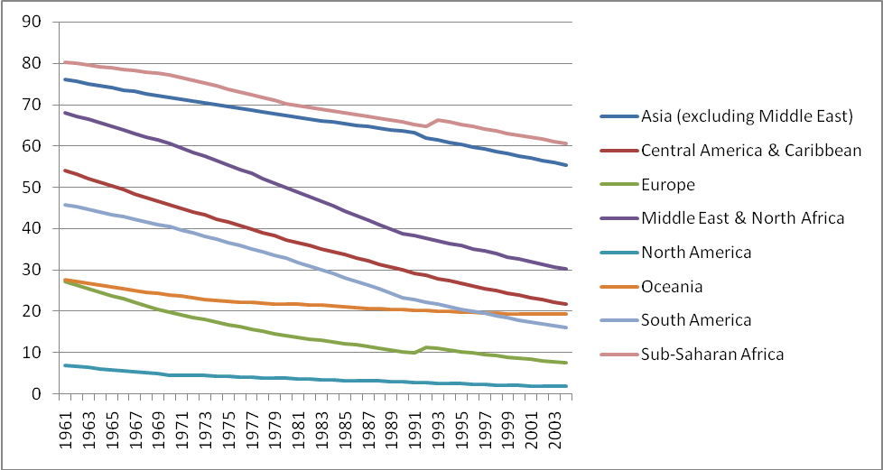

WDI online, agricultural labor force as % of total, 1991 to present based on ILO estimates (before 1991 not available).

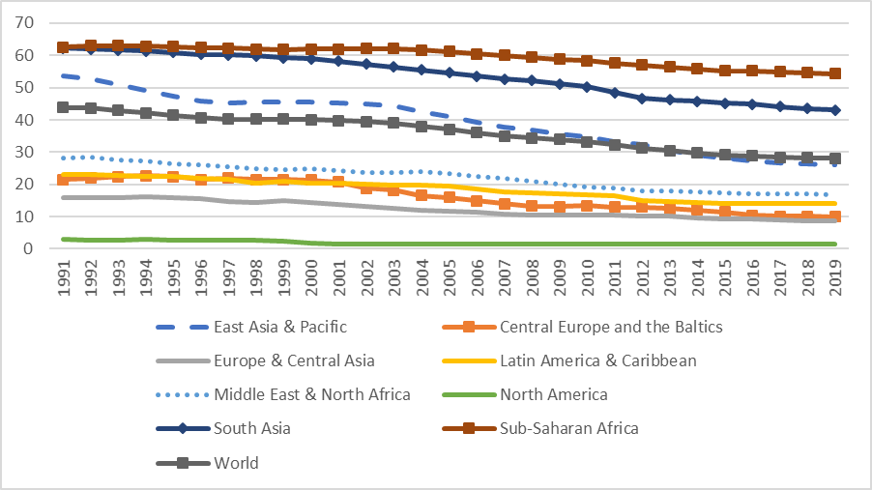

Agriculture tends to account for a larger share of employment than of GDP.

[http://data.worldbank.org/topic/agriculture-and-rural-](http://data.worldbank.org/topic/agriculture-and-rural-development) [development](http://data.worldbank.org/topic/agriculture-and-rural-development)

Gender patterns

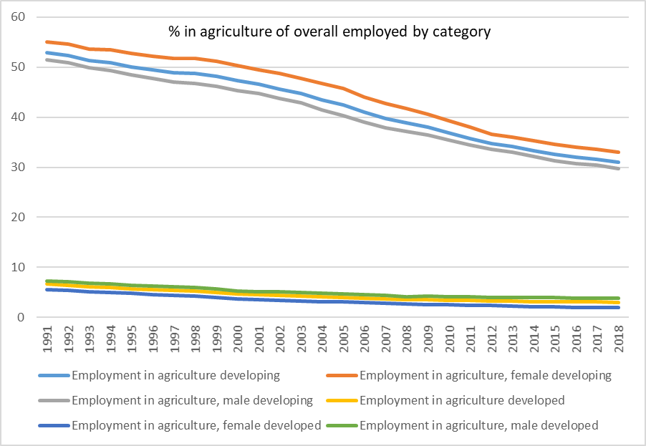

Note some gender dimension with females more involved than males in developing countries – slight opposite in developed.

The fact that the share of the labor force in agriculture is relatively high and the share of agriculture’s contribution tends to be low suggests a focus on agriculture might be a way to reduce poverty.

Historical views: (from Staatz and Eicher)

Passive role to agriculture during the 1950’s (the early phase of thinking about development).

Development was seen as structural transformation of the economy, leading to a decline in agriculture’s share of GNP and the share of the labor force employed in agriculture.

Working from the observed fact that as income grows, the share of agriculture in the economy declines. (recall the Kuznet’s characteristics)

An example is the Lewis model (1954) that we considered earlier in the course.

The rural areas are a source of labor and food for the urban sector. Focus is on drawing “surplus labor” from rural areas.

A different source of the view that the focus of development should not be on agriculture is due to Prebisch and Singer which we also talked about earlier in the course.

They pointed out that there is a tendency for the commodity terms of trade to turn against countries that export primary products and import manufactures. This limits the prospects of growth through primary product export.

Recall the commodity terms of trade discussion, with price index of exports divided by price index of imports.

Why? As we noted:

1. Engel’s law – income elasticity of demand is lower for primary commodities than for manufactured goods.
2. In addition, saw evidence of substitution of synthetic for natural resources (jute, sisal for example).

Hirschman (58) focused on linkages and integration. Recall our discussion of forward and backward linkages.

The argument was that industry has more backward and forward linkage potential than agriculture. Thus emphasize industry to get multiple effects.

To the extent that there was investment in the agricultural sector, it was based on diffusion of developed country practices to developing country farmers.

A package was extended, with the idea that adoption would lead to rural transformation (and non-revolutionary transformation at that).

It was also assumed that developing country farmers were inefficient, and could adopt efficient practices developed in the advanced countries.

By the mid 1960’s, there began to be a view that the ag sector was more than a passive force in development, and could play a role.

Two main themes came out of actually working in rural areas, rather than basing theoretical models on developed country history.

1. Structural impediments (social and political) limited the ability of rural producers to adopt extended technologies. Marxist critiques played a role here.
2. Rural farmers were responsive to useful things, not tradition bound lumps. If they did not adopt something, maybe they had a reason.

Schultz described rural farmers as efficient but poor (1964).

He suggested there was not output growth waiting to happen by a reallocation of existing resources.

People who lived in these environments had worked out over time reasons for allocating resources the way they did. New agricultural technologies would be needed.

So new research institutes were developed. The Consultative Group On International Agricultural Research (CGIAR, the CG system).

Link concept of land grants here and CGIAR’s. Funding from countries, UNDP, FAO, WB, ADB, Ford Foundation,…

<http://www.cgiar.org/about-us/>

|  |
| --- |
| **The Consortium of Centers is a new legal entity that was established to lead, coordinate and support Center research. Toward this end, it is guiding the formulation of the CGIAR's Strategy and Results Framework together with a portfolio CGIAR Research Programs. As the counterpart of the CGIAR Fund, the Consortium implements these programs through Centers and their partners, based on performance agreements between the Consortium and Fund.** |
| P80C3T1#yIS1 |
| [Africa Rice Center](http://www.warda.cgiar.org/) [Bioversity International](http://www.bioversityinternational.org/)  [CIAT - Centro Internacional de Agricultura Tropical](http://www.ciat.cgiar.org/) [CIFOR - Center for International Forestry Research](http://www.cifor.cgiar.org/)  [CIMMYT - Centro Internacional de Mejoramiento de Maiz y Trigo](http://www.cimmyt.org/) [CIP - Centro Internacional de la Papa](http://www.cipotato.org/)  [ICARDA - International Center for Agricultural Research in the Dry Areas](http://www.icarda.cgiar.org/) [ICRISAT - International Crops Research Institute for the Semi-Arid Tropics](http://www.icrisat.org/) [IFPRI - International Food Policy Research Institute](http://www.ifpri.org/)  [IITA - International Institute of Tropical Agriculture](http://www.iita.org/) [ILRI - International Livestock Research Institute](http://www.ilri.org/) [IRRI - International Rice Research Institute](http://www.irri.org/)  [IWMI - International Water Management Institute](http://www.iwmi.cgiar.org/) [World Agroforestry Centre (ICRAF)](http://www.worldagroforestrycentre.org/)  [WorldFish Center](http://www.worldfishcenter.org/) |

These began in the 1970’s. Why?

1. Response to underdevelopment critiques.
2. Response to observing the empirical fact of political disasters (rapid growth in Nigeria followed by Biafra war, India and Pakistan and Bangladesh with conflicts, larger cold war strategies).
3. Realization that the poor were not benefiting in many cases from existing approaches.
4. Realization that urban sector could not keep up with labor force growth.

These institutes generated a great deal of empirical research on the nature of agricultural growth and technology adoption, rural labor market functioning and the relationship to migration, agricultural – rural economy linkages, market chains, farming systems research.

Piles and piles of microlevel research.

Also many worked to build up host country / national research capacity (NARS in dev speak).

Integrated Rural Development.

1. Increase output growth of small farmers (technology, prices, institutions)
2. Increase demand for domestic production by urban consumers (healthy urban sector and strong linkages)
3. Increase diversified base of rural economy that are complements to the agricultural economy.

Basic Needs. Growth with equity. Focus on women. Focus on poverty. Explicit attention on health and nutrition. All these lead to a broader view of the agricultural sector.

The 80’s began a swing back to macro perspectives as we link back up with the Washington Consensus policy issues noted earlier in the course.

There were concerns about how far it was possible to go addressing basic needs without also having structural reform to allow sustainable economic growth.

In the agricultural sector:

Led to policies to move government out of marketing, end of integrated monopsonist commodity parastatals.

Exchange rate issues were discussed – overvalued currencies were a disincentive for farmers who wanted to export.

“Getting prices right”.

Moving toward microeconomic and macroeconomic integration. “Are macroeconomic reforms microeconomically coherent?” For example, households may be both producers and consumers of a commodity such as rice (think of seasonal issues). What is net effect of letting the price fluctuate? Also, the static nature of the macro models are being challenged by greater understanding of the role of risk and vulnerability.

Move to the Todaro chapter, to get a different perspective on agriculture.

Food Production and Per Capita food production are for the most part increasing, but not at a very high rate. 1% per year or so.

FAO Stat food production index.

On a Per-Capita basis

You can compare to GNP growth rates to ag sector growth rates. Agricultural sector growth rates tend to be below overall GNP growth rates.

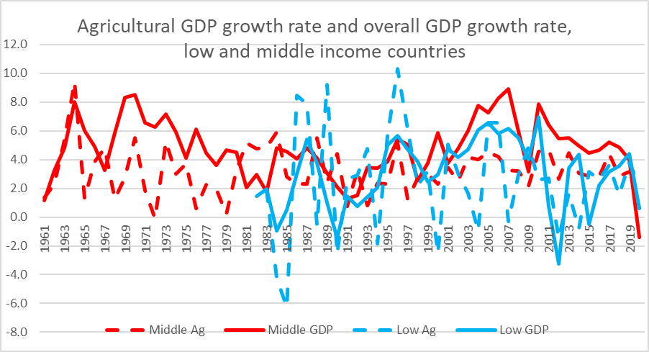

WDI Online

|  |  |  |
| --- | --- | --- |
|  | Average | Variance |
| High-Agriculture | 1.3% | 12.5% |
| High-GDP | 3.0% | 4.0% |
| Middle Agriculture | 3.2% | 2.6% |
| Middle GDP | 4.8% | 4.2% |
| Low Agriculture | 2.6% | 14.7% |
| Low GDP | 3.0% | 5.2% |

What are the structural characteristics of agricultural production we need to know about?

First, we need to be aware that “dual economy” issues may be relevant here.

There is commercial, mechanized, low labor high capital input, high productivity farming.

There is subsistence, high labor low capital input, low productivity farming.

A productivity gap. The cash value of output per farmer. Two ‘types’ of agriculture can exist side by side in developing countries, one a developing country ‘type’ and the other a developed country ‘type’.

For a historical sense of change over time, developed country output was 13 times greater than developing country output in 1960, 50 times greater in 2000.

Land productivity. Kilograms of output per hectare from World Resources Institute’s discontinued Earthtrends

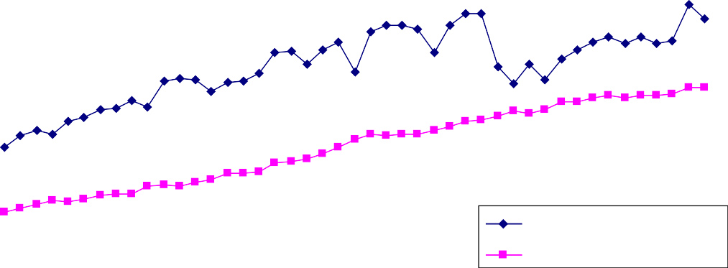

**Yield per hectare of grains**

4500

4000

3500

3000

2500

2000

1500

1000

500

0

Developed Countries

Developing Countries

1961

1964

1967

1970

1973

1976

1979

1982

1985

1988

1991

1994

1997

2000

2003

WDI, Cereal yield per hectare over time.

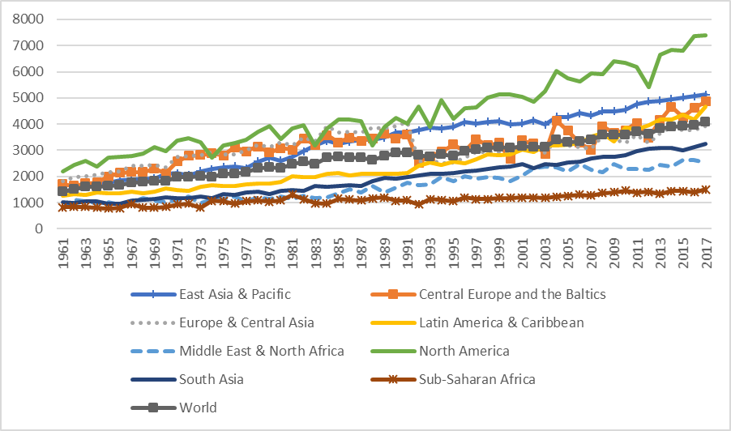

From an FAO study on agricultural productivity “Agricultural Investment and Productivity in Developing Countries” (Zepeda, 2001)

|  |  |  |
| --- | --- | --- |
| **Indicator** | **Sub-Saharan Africa** | **World** |
| Fertilizer use (kg/arable ha, 1995) | 13 | 94 |
| Tractors (per 1 000 ha cropland, 1993) | 3 | 21 |
| Ag output growth (percent/yr, 1980-1990) | 1.8 | 2.8 |
| Ag output growth (percent/yr, 1990-1996) | 2.1 | 1.7 |
| Cereal yield (kg/ha, 1980) | 1 100 | 2 230 |
| Cereal yield (kg/ha, 1995) | 1 041 | 2 561 |
| Ag productivity (US$/ha, 1993) | 68 | 236 |

Developed country agriculture output per hectare is 2-5 times greater than the output for the same amount of land in developing country agriculture. Note this is higher output, but also higher cost given input use noted above (if we think of profit =p*q-c(q), $ per ha is higher but so is cost.

We can identify three main types of agrarian systems throughout the developing world.

1. Agricultural dualism (latifundio-minifundio). Frequently observed in Latin America, but also exists in other areas. Colonial history. A few landowners hold a vast majority of the land. High Gini coefficients for land distribution (in the 0.8 to 0.9 range). Roughly 90% of the farms occupy less than 17% of the land.
   1. Does this reflect economies of scale / capital intensive production has high land requirements? Inverse relation between farm size and productivity. Smaller farms are lower cost producers of a given quantity of output. Smaller farms produce more per unit of land. Land is used less efficiently in the large farms and labor is applied intensively in small farms. Land tenure reform, land redistribution, training, and access to credit can be a way of increasing national output and addressing poverty of the small farmers.
2. Absentee landlord / tenant farming / sharecropping systems. Frequently observed in Asia. Village distribution of land through central village authority was transformed during colonial era to landlord – tenant system. Absentee owners of land (which is a bit different from the patron living on the land in the latifundio system). Around 85% of tenanted land is sharecropped in Asia, and the majority of the land in many Asian countries is tenanted land. Role of the moneylender (or food / input lender) in concentrating tenure in a few hands.
   1. Note economic efficiency argument that resources will end up in the hands of the most productive user. Is this the case here? Again, land tenure reform, land redistribution, training, and access to credit can be a way of increasing national output and addressing poverty of the small farmers.
3. Land abundant, extensive cultivation. Frequently observed in Africa. Some land is unused since constraint is labor and low technological inputs. Planting by hand, using an ax or knife. Traction limited by tsetse fly. Intense cultivation of one field gives way to intensive cultivation of another – shifting cultivation. Limits need for fertilizer. Labor constraints are seasonal, but seasonal constraints limit output. Rainy seasons one or two times per year, weeding / planting / harvesting all falls within a certain window. Leads to seasonal underemployment.
   1. This system is coming under pressure as population grows and formal economy and state presence grows. Here, you need technological improvements that allow more intense cultivation of given land, release labor constraint (without requiring high capital inputs and displacing workers).

Land Reform:

Why would we think land reform to provide formal tenure is a good thing?

1. Incentive to invest.
2. Investment horizon extended.
3. Credit access and collateral.

When might it not work out as anticipated?

1. Weak states lead land allocation to follow political rather than efficiency arguments in distribution:

Platteau. (Dev and Change, 1996) Land tenure registration can in fact be risk increasing for rural farmers in a context where traditional rights exist and are understood, but a competing formal system is designed in a system where political power influences who gets deeds.

1. Land reform takes place in contexts where there is ambiguity over rights, leading to conflict.

In Senegal there was a project to reclaim rice lands lost to salt intrusion through the construction of barriers. Land conflict arose between villages over the reclaimed land.

1. Ambiguity in land rights is a risk mitigating mechanism. Pastoral land examples.

What other options for improving agriculture are available? How can we improve small scale agriculture?

* 1. Technology and innovation.

Technology tends to be labor saving, which is not always the best idea.

Technology also can require capital investment, which can be a problem.

Challenge to design low capital cost, non labor replacing, scale neutral technologies. Agroforestry, intercropping. Seed storage.

Challenges 1:

The social context of production.

Tasks in agriculture are often “gendered”. Women transplant rice, men clear fields, women harvest rice,…

Crops grown can also be “gendered”. Women grow rice, men grow peanuts.

Particular issues arise when women grow subsistence crops and men grow cash crops. How will inputs be purchased (issues of cash from husband and access to formal credit arise)? What crops will extension services target (extension agents are usually staffed by males)? What happens when a subsistence crop moves into the cash crop domain?

In Gambia the introduction of commercial, large scale rice production schemes moved rice production from a “women’s” crop to a “men’s” crop.

Milk marketing example from northern Kenya. Senegal Peace Corps rice program.

IRRI had developed IR-8, a green revolution crop. A rice breeder had crossed it with local varieties. It has performed extremely well in on research station trials. But there was little interest in extension from the national ag extension agency.

Rice is grown by women in the area. Rice is not a cash crop.

Baseline studies to establish growing practices and varieties in the area.

“Loan” of 2 kilograms of rice seed. Loan is to be returned at the end of the season. We monitor the plot, and a traditional rice plot next to the trial plot. A few techniques go with it:

Tilling depth, manure, and plant density in seedbed. Transplant period of 21 days.

Transplant density.

Overall first year yield improvement of 13% for transplanted rice and 21% for direct seeded rice. In

adoption literature, you need to get 20% to 30% to have some confidence of widespread adoption. For people who followed all the recommendations, the results were better suggesting things would catch on. They were, at least during the 1992 season when I left.

APEX project in Mali. Increasing the commercialization of traditional poultry production. Rural Malian women were trained in how to build improved structures for their poultry. Also, they were trained in the use of commercial feed and veterinary inputs. However, no commercialization training in the marketing of poultry.

Net loss (moved from no-input high mortality to high input low mortality program. That is a success, but need marketing to increase as well).

Challenges 2:

Risk

Risk minimization. The consequences of failure are severe. Farmers may stick with tried and true low mean low variance techniques and crops, even when extension programs are demonstrating new techniques that appear to offer higher returns.

Also, can explain sharecropping as a response to risk. I accept a lower share of the annual return even though I did all the work in return for which the landlord guarantees me food in the crisis. Exploit me now, insure me later.

Resistance to proposals may not be a manifestation of traditional stubbornness, but a response to the farmer’s assessment of the risk or a lack of understanding of the larger context of production by the extension agent.

Our insurance in Kenya has found what other insurance programs have found; the wealthier and less risk averse are the ones to buy insurance.

* 1. Institutional and Pricing reform.

Prices fixed by state boards, often to keep food prices low in the city. Reduce role of marketing boards (but who will fill the gap?)

Mali project again. Improved fodder production through planting or urea enriched straw. It was economically profitable, but the inputs (seeds and urea) were not easy to get.

Cottonseed cake is the main input for fattening livestock, but cotton sector parastatal was privatized and broken up. Now there are problems with quality heterogeneity in feed markets and lack of consistent market supply. [note NIR as a possible response]

Policies that allow price systems to create market incentives can work (but how to do so without exacerbating risk?).

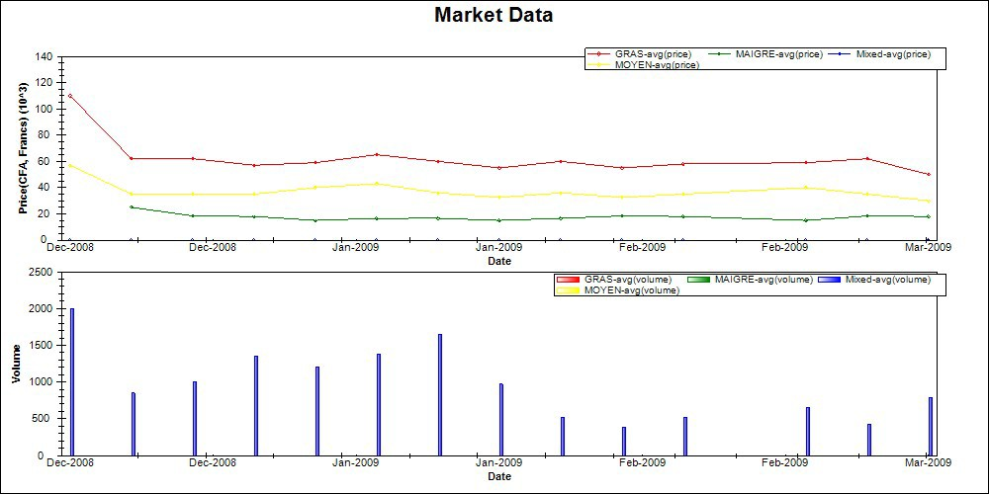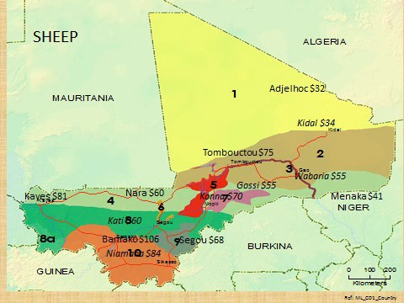

Policies that provide access to credit, inputs, and information can help.

Kenya work: climate information research. Information without capacity to act is not going to have a major impact. Also note market information findings with only 12% of sample saying they sought price information over a 10 year period.

Policies need to recognize that the agricultural sector is but one component of the overall rural economy. As we have noted before, there is a great deal of income diversification even in rural areas. We must be aware of how efforts to improve agriculture impact these other activities, and how we can increase agricultural output by increasing these activities.

We also should be aware that priorities of people in rural agricultural areas may not be on agricultural development. Senegal River Valley work by IDA in the 90s.

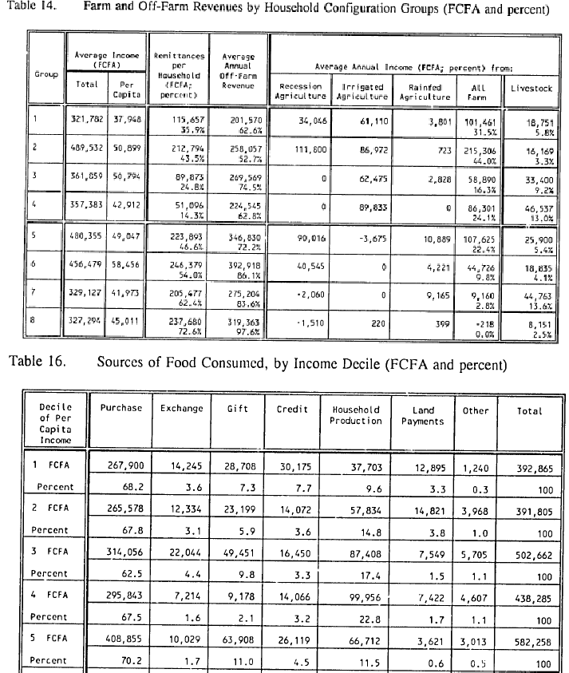

Integrated rural development – agriculture as a foundation of the rural economy, but linked with alternative income generating activities, improved access to public goods and social services.

Policy Summary:

Land Reform

* Inverse Farm Size – Productivity
* Incentive to invest / not degrade
* Collateral
* Equality enhancing.
* Problems with weak states, not market allocation
* Problems with non-compensation
* Problems with ambiguity of ownership and traditional land tenure system
  + Risk minimizing ambiguity
* Problems when not a component of broader program

Technology and Innovation

* Low capital cost, fit in labor profile, scale neutral (agroforestry, IPM, ...)
* Non risk enhancing / mean variance issues
* Fits existing age / gender patterns or is at least aware of them
* Problems when not part of a broader program

Institutional Change

* Market institutions to increase volume and efficiency
* Privatization without loss of complementary services
* Appropriate credit
* Risk minimizing, security enhancing
* Information enhancing

Broader Rural Development

* Overall quality of lives improved
* May not be about agriculture