Problem Set 8 Solution Key
PPA 723
Prof. John McPeak

Answer 1. Calculation of final payoffs
No. of Cows |  |  | Milk Produced |  |  | Cost |  | payoff
Herder 1 | Herder 2 | Total | Total | Herder 1 share | Herder 2 share | Herder 1 | Herder 2 | Herder 1 | Herder 2
(A) | (B) | C= (A+B) | (D) | E=(A/C)*D | F=(B/C)*D | G= 1*A | H= 1*B | E-G | F-H
0 | 0 | 0 | 0 | 0 | 0 | 0 | 0 | 0 | 0
0 | 1 | 1 | 5 | 0 | 5 | 0 | 1 | 0 | 4
0 | 2 | 2 | 8 | 0 | 8 | 0 | 2 | 0 | 6
1 | 0 | 1 | 5 | 5 | 0 | 1 | 0 | 4 | 0
1 | 1 | 2 | 8 | 4 | 4 | 1 | 1 | 3 | 3
1 | 2 | 3 | 9 | 3 | 6 | 1 | 2 | 2 | 4
2 | 0 | 2 | 8 | 8 | 0 | 2 | 0 | 6 | 0
2 | 1 | 3 | 9 | 6 | 3 | 2 | 1 | 4 | 2
2 | 2 | 4 | 9 | 4.5 | 4.5 | 2 | 2 | 2.5 | 2.5

Final Payoff Matrix
 |  | Herder 2
 |  | 0 | 1 | 2
Herder 1 | 0 | 0,0 | 0,4 | 0,6
 | 1 | 4,0 | 3,3 | 2,4
 | 2 | 6,0 | 4,2 | 2.5,2.5

- Best Response Strategies
For Herder 2
If Herder 1 has 0 cows, herder 2 chooses 2 cows
If Herder 1 has 1 cow, herder 2 still chooses 2 cows
If Herder 1 has 2 cows, herder 2 still chooses 2 cows
For Herder 1
If Herder 2 has 0 cows, herder 1 chooses 2 cows
If Herder 2 has 1 cow, herder 1 still chooses 2 cows
If Herder 2 has 2 cows, herder 1 still chooses 2 cows

- The outcome of the game is both herders choose to place 2 cows in the common pasture with the resultant payoff of 2.5 each. Both have dominant strategies.

- Calculation of New payoffs

No. of Cows |  |  | Initial payoff |  | New Payoffs
Herder 1 | Herder 2 | Total | Herder 1 | Herder 2 | Herder 1 | Herder 2
(A) | (B) | C= (A+B) | D | F | H=D+1*B | G= F-1*B
0 | 0 | 0 | 0 | 0 | 0 | 0
0 | 1 | 1 | 0 | 4 | 1 | 3
0 | 2 | 2 | 0 | 6 | 2 | 4
1 | 0 | 1 | 4 | 0 | 4 | 0
1 | 1 | 2 | 3 | 3 | 4 | 2
1 | 2 | 3 | 2 | 4 | 4 | 2
2 | 0 | 2 | 6 | 0 | 6 | 0
2 | 1 | 3 | 4 | 2 | 5 | 1
2 | 2 | 4 | 2.5 | 2.5 | 4.5 | 0.5

New payoff matrix
 |  | Herder 2
 |  | 0 | 1 | 2
Herder 1 | 0 | 0,0 | 1,3 | 2,4
 | 1 | 4,0 | 4,2 | 4,2
 | 2 | 6,0 | 5,1 | 4.5,0.5

- Best Response Strategies
For Herder 2
If Herder 1 has 0 cows, herder 2 chooses 2 cows
If Herder 1 has 1 cow, herder 2 is indifferent between 1 or 2 cows
If Herder 1 has 2 cows, herder 2 chooses 1 cow
For Herder 1
If Herder 2 has 0 cows, herder 1 chooses 2 cows
If Herder 2 has 1 cow, herder 1 still chooses 2 cows
If Herder 2 has 2 cows, herder 1 still chooses 2 cows

- While Herder 1 has a dominant strategy, Herder 2 does not. But Herder 2 knows that Herder 1 will always place 2 cows, herder 2 will then choose his best response which is 1 cow. (2,1) with payoffs (5,1). This is a Nash Equilibrium

- Total payoff in Nash equilibrium are higher than in dominant strategy outcome (6>5)

- While there has been a pareto improvement since the total payoff has increased but here at loss by herder 1 and gain by herder 2
- & i) If each herder is allowed one cow each, then the pay offs would be (4,2) where the total payoff is equal to the tenure reform policy.

Ques 2 a) Here payoffs of the coal burning plant are unaffected by the level of clothesline used by laundry, but the payoff of the laundry gets reduced if there is high level production by coal. Hence Coal plant imposes a negative externality on the laundry firm.

b) The nash equilibrium is high production by coal and low level of clothes line by laundry with the payoff of (14,2) respectively

c)If laundry has a first mover advantage, then there would not be any change since both have their dominant strategies.

Ques 3 Demand Curve: P= 100-Q
Supply Curve: P=10+Q

- In case of perfect competition, DD=SS
100-Q=10+Q
2Q=90
Q=45
P=55

- MCE =0.5*Q
Social cost curve (Social Cost curve): P= 10+Q+0.5*Q
New Equilibrium at DD=SCC
100-Q=10+1.5 Q
90=2.5Q
Q=36
P= 64

- Let the per unit pigovian tax be t
Method1: at Q = 36,
MCE=0.5*Q= 18
Therefor, t=MCE= 18

Method 2: at Q=36, Total price or SCC should be 64
- 64= 10+ Q + t
- 64 = 10+36 +t
- t = 64-46 = 18

- No it does not matter where we place the tax and the tax burden is shared among the producers and the consumers.
- Incase of a monopoly
MR=MC
100-2Q=10+Q
Q= 30, P=70

f)
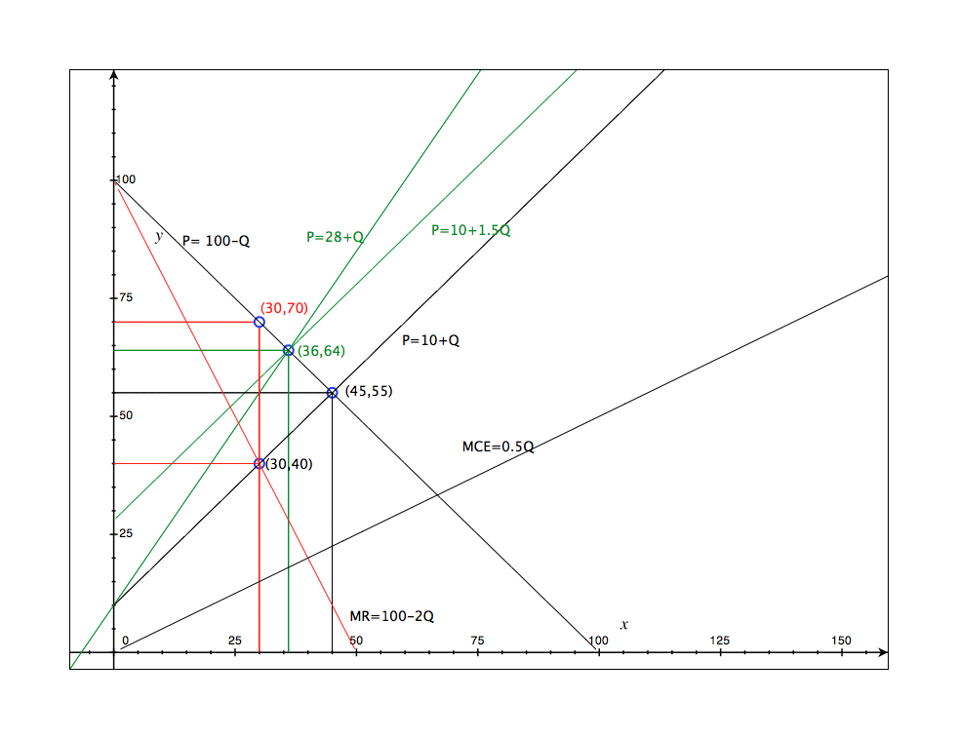

 | PC | MONOPOLY
PS | 1012.5 | 1350
CS | 1012.5 | 450
NEGATIVE EXTERNALITY | 506.25 | 225
TOTAL SOCIAL WELFARE (PS+CS-EXT) | 1518.75 | 1575

